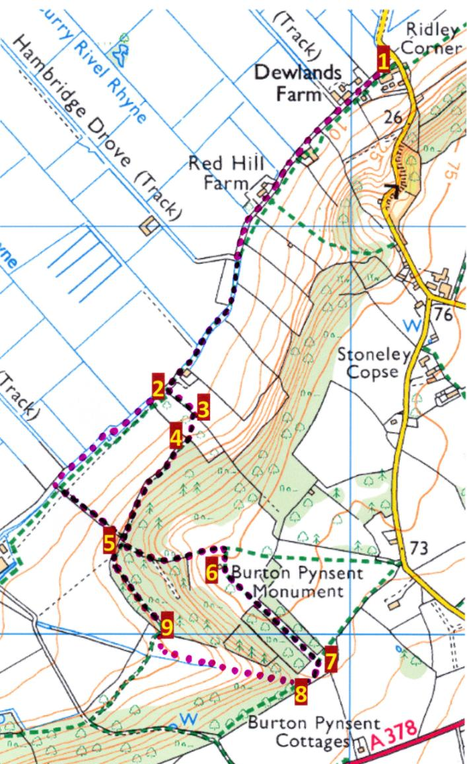

Find somewhere to park at the bottom of Red Hill or, if an RSPB member seek permission to park in Dewlands Farm yard. Just below the farm is the end of South Drove **1**. Walk along there a fairish distance until you have passed an attractive farmhouse on the right and a barn conversion about 1Km further on on the left. Soon after this there is a footpath off to the left **2** - a muddy slope down and across a bridge and up the other side. Walk up through this field to a stile on the right **3** - this can be a bit difficult for some dogs. Cross another field which contains apple trees and through the gate opposite or over the stile alongside **4**. Continue through the woods and through another gate or over the stile until you come to a stile on the right **5** and a path up the hill through the woods towards the monument. Go up here - it is a bit steep but fairly short. Go through the gate and continue up the field to the monument **6**. Brilliant views and worth a stop to admire and to look at some of the initials carved into the Monument.

When ready, walk onwards across the field between two wooded areas and out the other side **7**. The actual right of way goes straight on angling slightly to the right between two rows of trees and then down a drove but I have always gone almost immediately right **8** and down the field which is steep but has really beautiful views over Sedgemoor. Towards the bottom of the field there is a Bristol gate on the right **9** back in to the woods and a path more or less straight ahead. Continue until you see a stile on the left and the path you climbed earlier on the right. Go over the stile which has a dog gate alongside and walk through a small piece of woodland and down the field back to South Drove. Turn right when you reach there and walk back to your car.

**Walk 9**

**Burton Monument from Dewlands Farm**

Distance x km (y mls) along South Drove, and through woods and fields